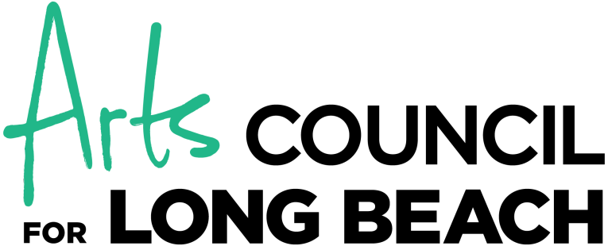

RISK AND INNOVATION GRANT
FY 2016–2017 APPLICATION

PART I: APPLICATION CHECKLIST
(Submit the application packet checklist as your cover sheet, with each requested item checked off.)
Application and artistic documentation should be emailed to: lisa.desmidt@artslb.org:
Artist(s) Profile/Application Form
Artist/Group Statement
Biography of Collaborators, if any
Narrative Information
Sample of Artistic Work (as described under the documentation section)
Marketing Materials (as described under the documentation section)
Project Budget
Letter of Agreement, signed and dated
C.V. or Résumé (two pages maximum)
Letter of Recommendation, signed and dated
Proof of City of Long Beach Artist Residency. Submit a copy of one of the following: valid CA Driver License, valid U.S. federal, state or local government issued ID, utility bill of the applicant that is dated within 90 days of the aplication deadline, business license, rental agreement, consistent pay stubs or alternate form of proof of living, working or actively creating in Long Beach.

PART II: ARTIST(S) PROFILE

HOW TO SUBMIT YOUR APPLICATION – DEADLINE SUNDAY, April 30, 2017
Please type in minimum size 11 font. All submissions should be emailed to: lisa.desmidt@artslb.org. No hard copies will be accepted.
For questions, call: (562) 435-ARTS ex: 104
CONTACT INFORMATION
Applicant Name (individual or group):
Legal Name: |  |  | Popular Name:
Mailing Address:
City: | State: |  |  |  | Zip:
Phone (work or daytime): |  | Email:
Social Security #: |  | Website:
How should the Applicant be acknowledged in publicity materials:

Long Beach City Council Districts where you reside:  1 2 3 4 5 6 7 8 9 |  | Long Beach City Council Districts where program/performances will take place (Check all that apply):  1 2 3 4 5 6 7 8 9
Artistic Discipline (check one):

Visual Arts Media Arts Performing Arts Traditional/Folk Arts Literary Arts

Multidisciplinary Arts (please describe): Other (please describe):

Certification
I certify that, to the best of my knowledge, the application fully meets all of the eligibility requirements for the 2016–2017 Risk and Innovation Grant and the data in this application and all attachments are true and correct.
Applicant Signature: |  |  |  | Date:

PART III: ARTIST(S) STATEMENT

Please respond to the following statement in no more than one single-sided 8½ x 11” page with 1” margins. Number each page and indicate the Applicant’s name in the upper right of each page. Applications must be typewritten, single-spaced in 11-point font or larger.

- What is your Artistic Vision and Practice? (500 words max.)
- Describe your artistic practice, philosophy and creative process and highlight any major lines of artistic inquiry.
- Optional for traditional and folk artists: you may add one page to your Narrative that specifically discusses your traditional practice and the creation of new work in that cultural context. For example, how does your project uphold and/or expand traditional ideas of how your art form should be done?

PART IV: ARTISTS’/COLLABORATORS’ BIOGRAPHYIES

Provide a one-paragraph biography and description of roles for artists collaborating on the project.

Name: Title:

Name: Title:

Name: Title:

PART V: NARRATIVE SECTION
(Name in upper right corner on all pages, single line spacing, 11 point font, 1” margins, 2 pages max.)
PROPOSED PROJECT
- Proposed Project: Describe the proposed innovative and/or risk taking project. Include proposed performances, exhibitions or other project dates; project location(s); and the projected audience size(s). Include the goals and objectives of the project.
- Target Community/Core Audience: Describe the target community/core audience for the proposed project in terms of geography, age, cultural and economic characteristics, as applicable. Describe target community/core audience needs and how the project address and impacts needs.
- Publicity/Promotion: Briefly describe the ways in which the proposed project will be publicized and promoted.
- Similar Project: Describe a recently completed project of similar character and magnitude as the proposed project. Include outcomes, specific difficulties and sources of funding.
- Evaluation: How will success be defined for this project? Describe how the project will be evaluated. Describe other related evaluation systems the applicant has in place to promote excellence in the operations, programs, presentations, performances and personnel.

PART VI: ARTISTIC DOCUMENTATION AND MARKETING MATERIALS

Artistic documentation is crucial for evaluating the artistic quality of the applicant and/or project. Sample(s) should be recent, of high quality and as relevant to the application and/or project as possible. Label each sample clearly with the name of the applicant. Do not submit marketing/promotional materials as artistic documentation.

The Marketing Materials should include marketing/promotional materials such as season brochures, flyers, postcards, newsletters or reviews.

Preview the artistic documentation before submitting to ensure that there are no technical problems that might interfere with the panels review of the work. Panelists generally spend no more than three to five minutes on the work sample(s) for each application.

Specific Instructions for Artistic Documentation:

Images (via zip file, Drop box or Google Drive): Up to five images. Digital files of completed artwork. All images must be numbered (1 through 5). Digital files must be in JPG format, 300 DPI, 5MB or smaller.

Video link (strongly encouraged for Dance, Multi-Disciplinary, Media, Performing, Traditional and Folk Art): Up to five minutes. In general for the performing arts, panelists prefer to review substantive artistic excerpts rather than short edited clips with heavy narration.
Audio Link: (Strongly Encouraged for Music): Up to five minutes.

Published Material (strongly encouraged for Literary and Visual Arts): This format is best used for literary publications and museum and gallery catalogues.

PART VII: PROJECT BUDGET
Please provide a description of how you would use the $1,000 grant to support the project. If your project budget is more than the $1,000 grant please indicate where the additional funds will come from. Please note, the Arts Council does not fund through the Risk and Innovation Grant: projects which are not free and open to the public; fundraisers; purchase of works of art, purchase of land, buildings or construction services (capital expenditures); trusts or endowments; debt reduction efforts or ongoing deficit operations; programs with religious or sectarian purposes or that are part of scheduled religious services; expenses incurred before the start date of the grant contract or programs which aid or service political campaigns or political groups.

PART IV: BUDGET

INCOME – If your budget is over $1,000 please list additional sources of income.
ITEM (Please give details) | Cash | In-Kind*
1. Donations from Individuals
2. Arts Council for Long Beach Risk and Innovation Grant | $1,000
3. Donations from Businesses, Foundations, other Government sources (list)
4. Publicity/Marketing Donations
5. Other Donations (list)
Subtotals, Cash & In-Kind

TOTAL INCOME (Cash + In-Kind = Total Income. Total Income must equal Total Expenses)

EXPENSES
ITEM | Cash | In-Kind*
1. Artistic Fees
2. Materials/Supplies/Rentals (list)
3. Marketing (if applicable)
4. Other - (list)
Subtotals, Cash & In-Kind

TOTAL EXPENSES (Cash + In-Kind = Total Expenses. Total Expenses must equal Total Income)

*In-Kind = expenses you would normally pay cash for, but which are being donated.

